NAME-M.VIVEKVARDHAN
BATCH-12
2303A51765
TITLE-Implementation of a Simple Storage Smart Contract using Remix

CODE-
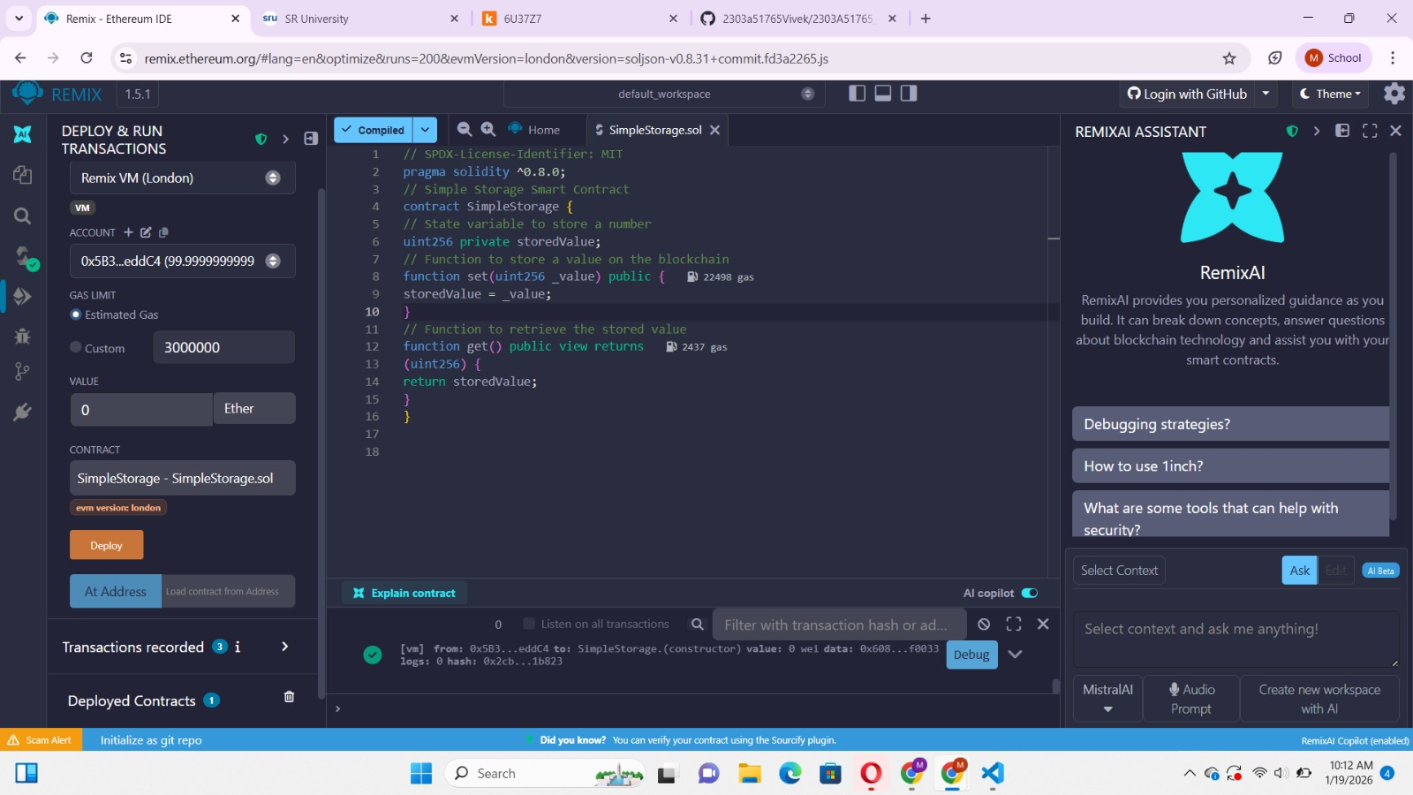

DEPLOY-

DEBUG-
